1. **Install Jenkins and run Jenkins on port number 8081.**

**1) Install Jenkins and run Jenkins on port number 8081.**

**Create EC2 and get package of jenkin from website and then install java.**

**Install java 17 version → sudo dnf install -y java-17-amazon-corretto**

**sudo yum install jenkins**

**sudo systemctl enable jenkins**

**sudo systemctl start jenkins**

**sudo systemctl status jenkins**

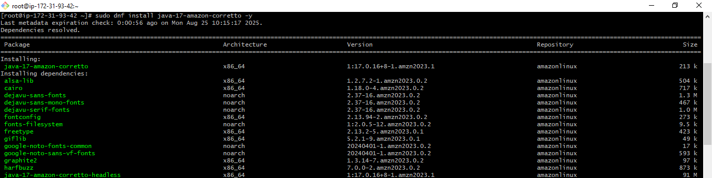

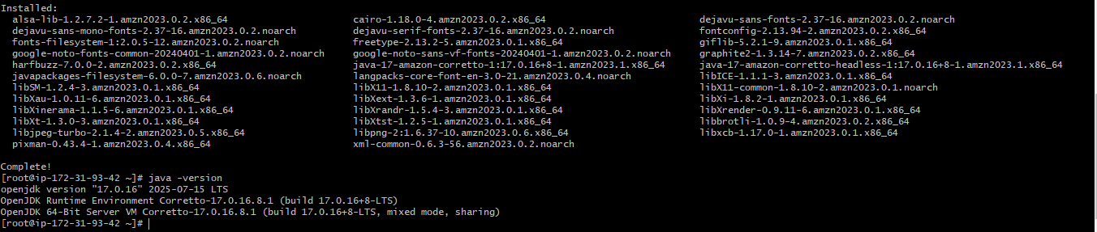

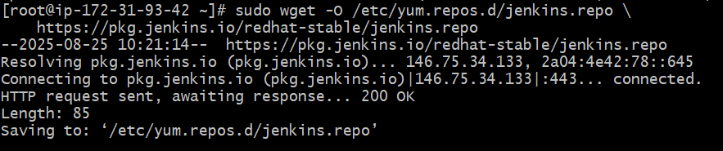

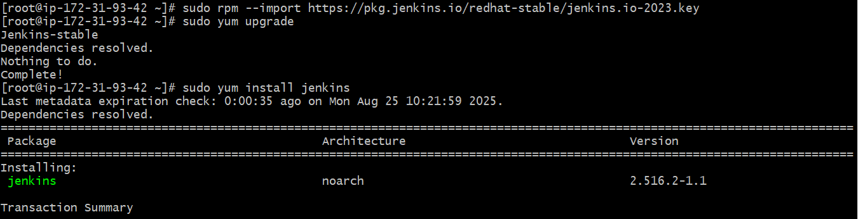

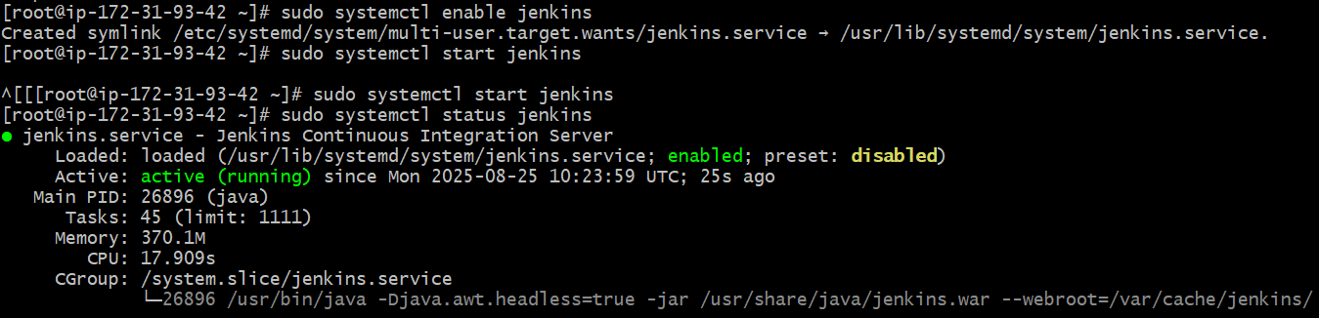

**Now changing port number to 8081**

**Now go to → sudo vi /usr/lib/systemd/system/jenkins.service**

**Update → Environment="JENKINS_PORT=8081"**

**sudo systemctl daemon-reexec**

**sudo systemctl daemon-reload**

**sudo systemctl restart jenkins**

**Now check in browser public-ip-of-EC2:8081**

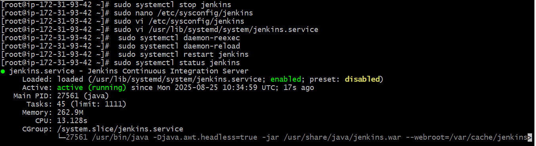

**If security group inbound rule are properly configure then go to browser and paste the public IP with port number 8081 will get this file.**

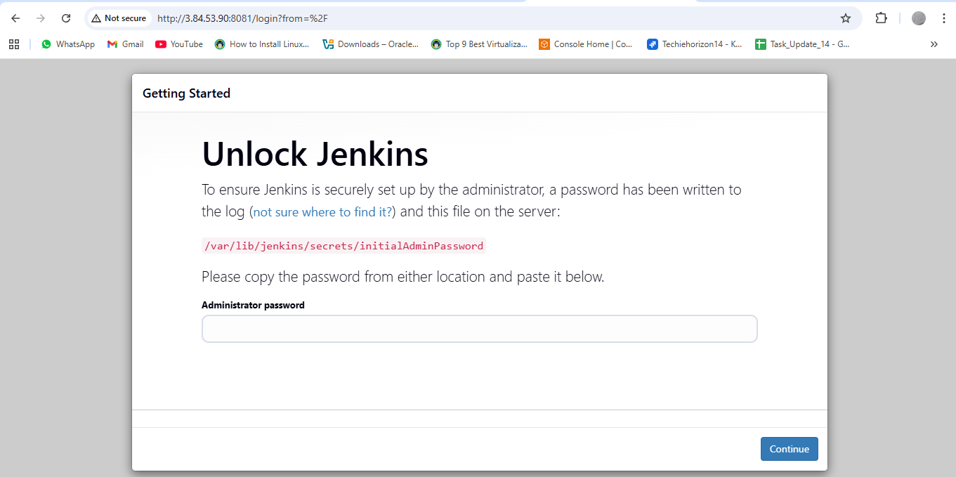

**Then copy the address and use cat command to get the password.**



**After apply the password select the option no:1**

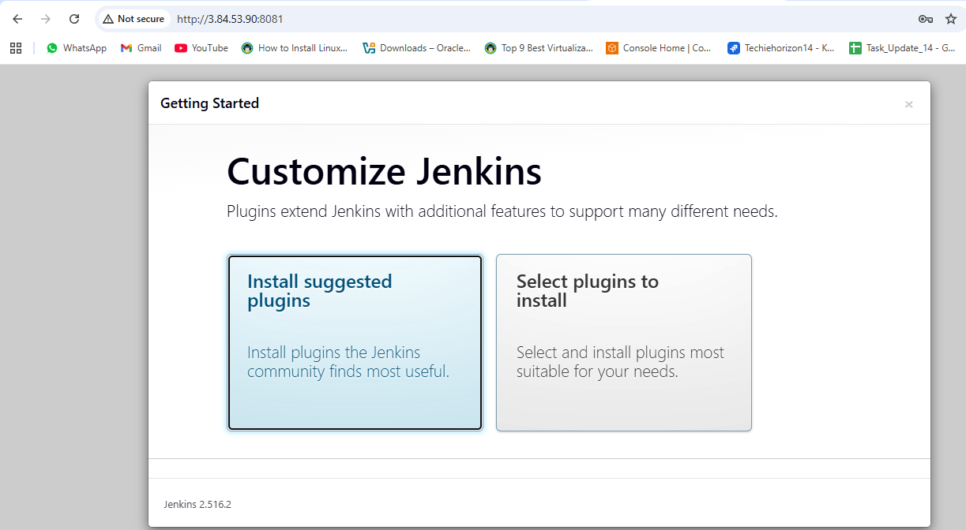

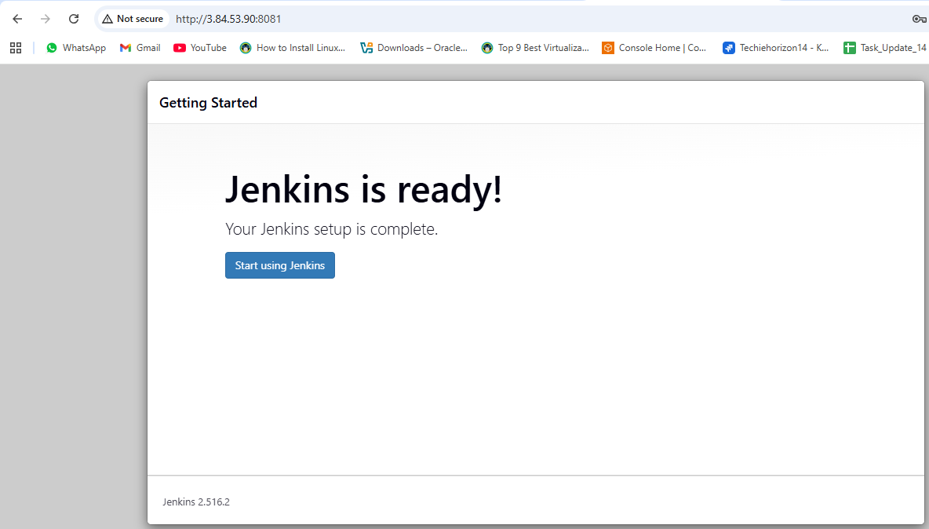

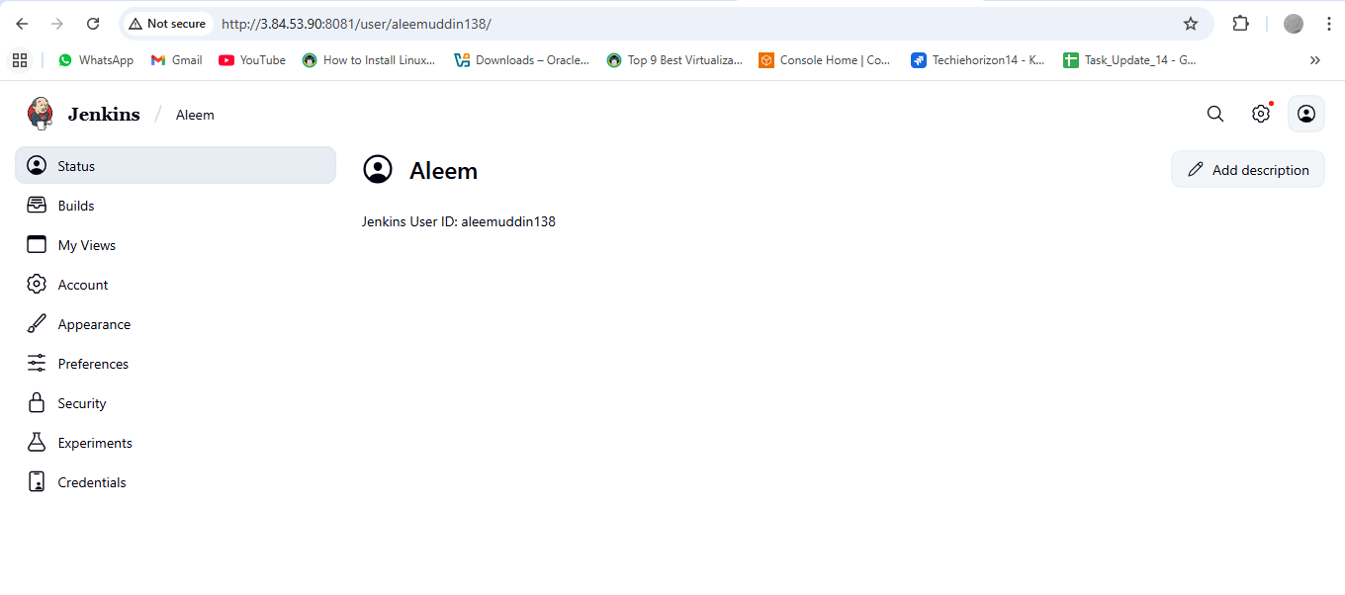

**2) Secure Jenkins server**

**Check the password and login to jenkins → cd /var/lib/jenkins/secrets**

**Cat initialAdminPassword**

**Now login to jenkins**

**Change password click on profile pic. jenkins → admin → security**

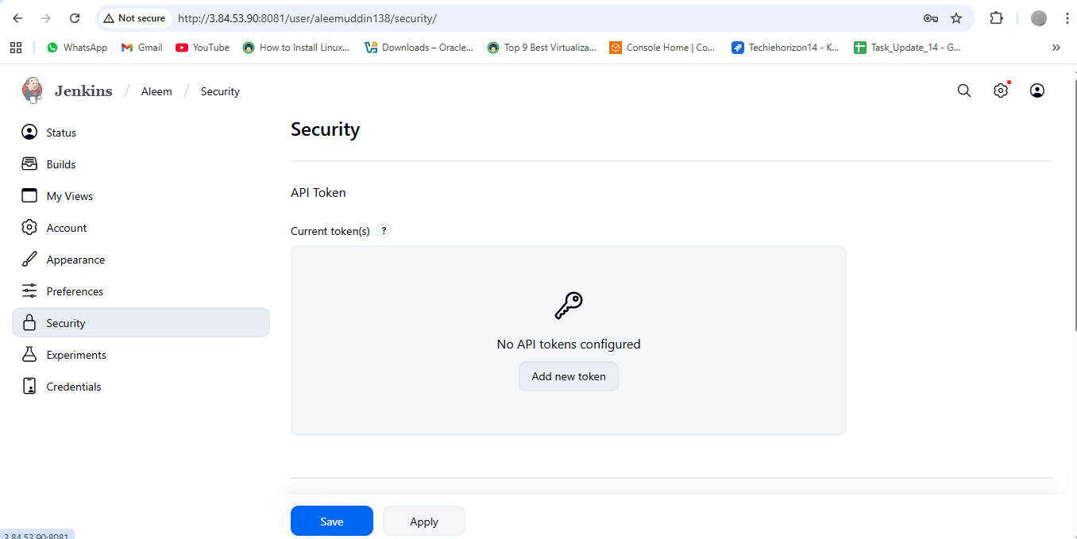

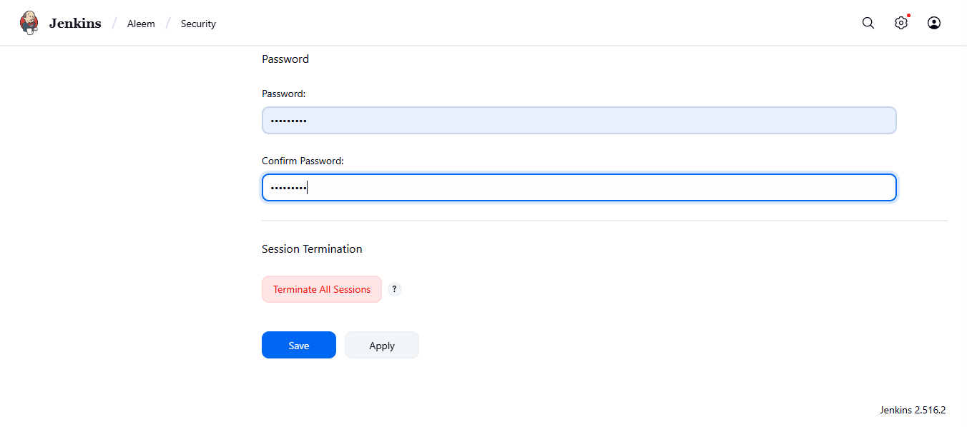

**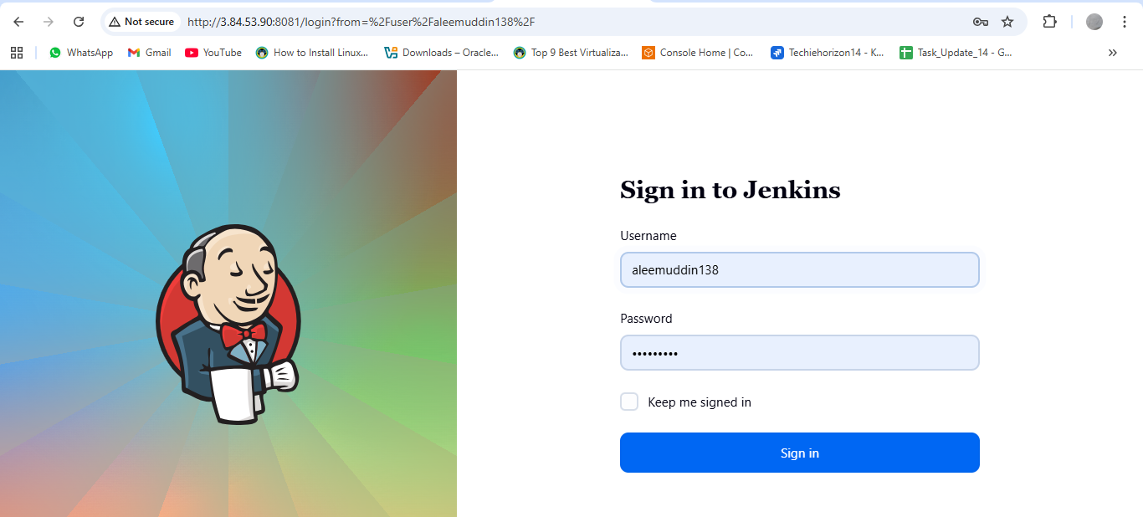  
3) Create users called DevOps, Testing in Jenkins with Limited access.**

**Goto → manage jenkins → users then create devops and testing users**

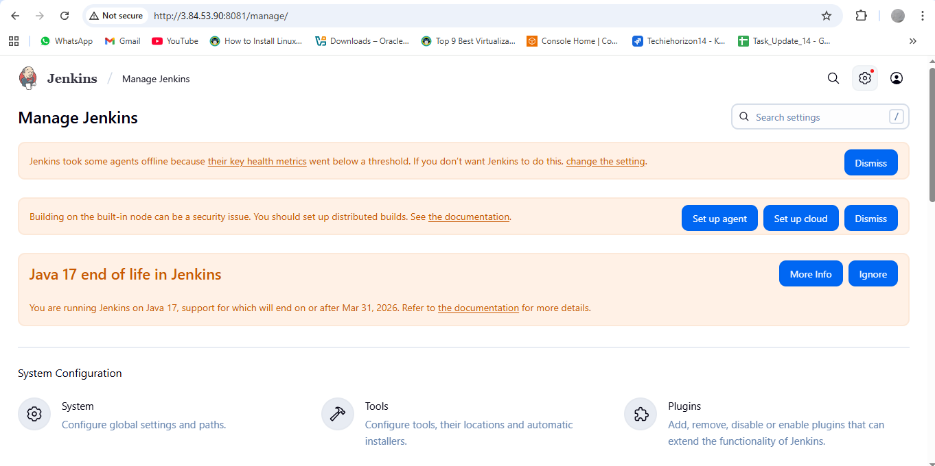

**Install plugin role-based authorization strategy**

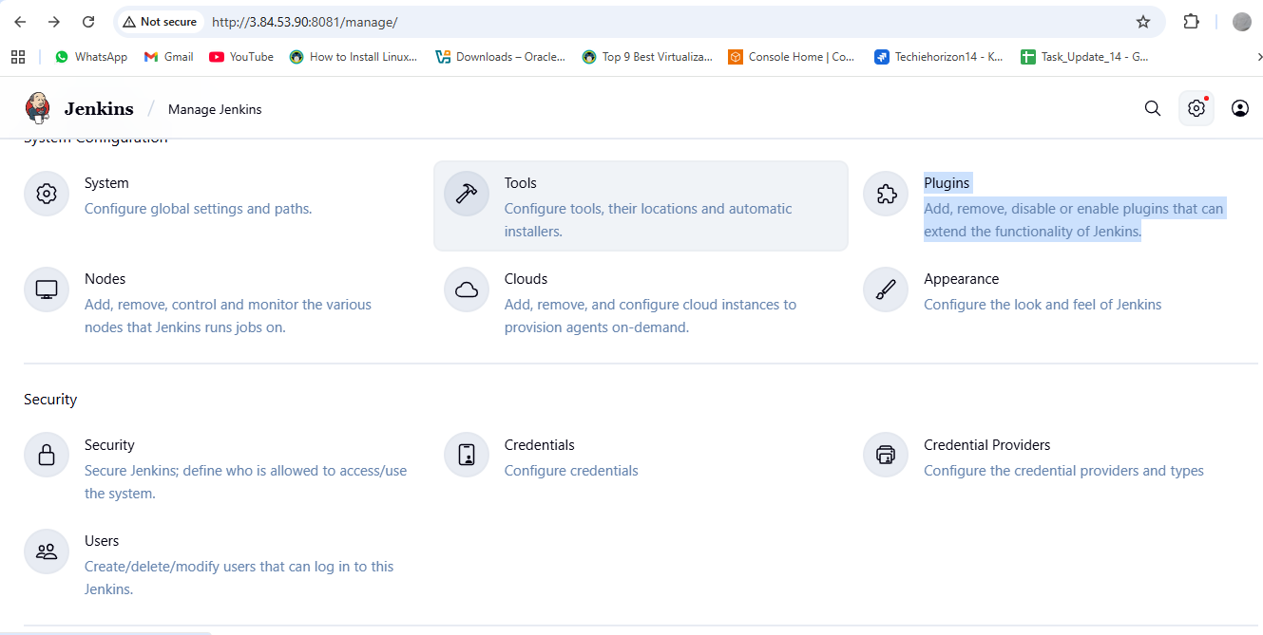

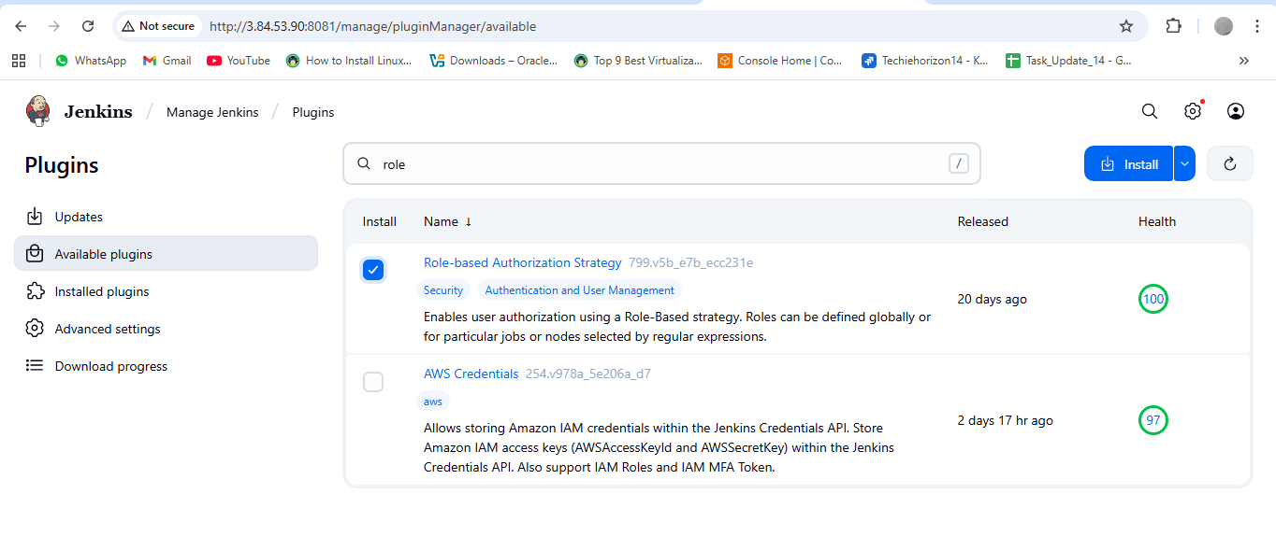

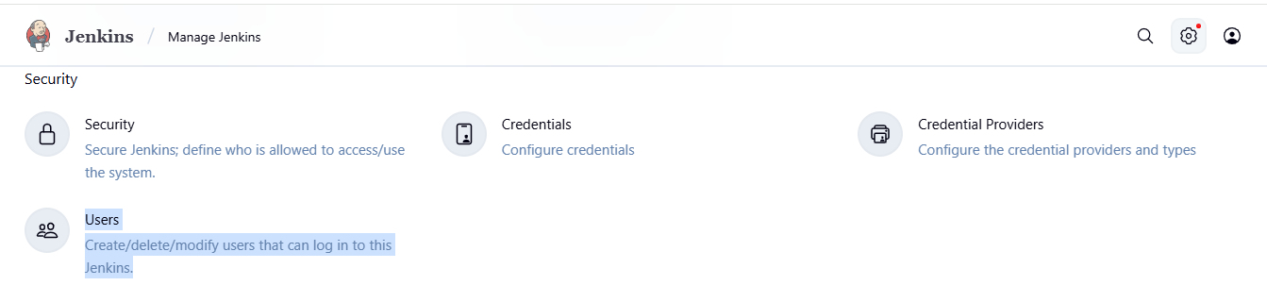

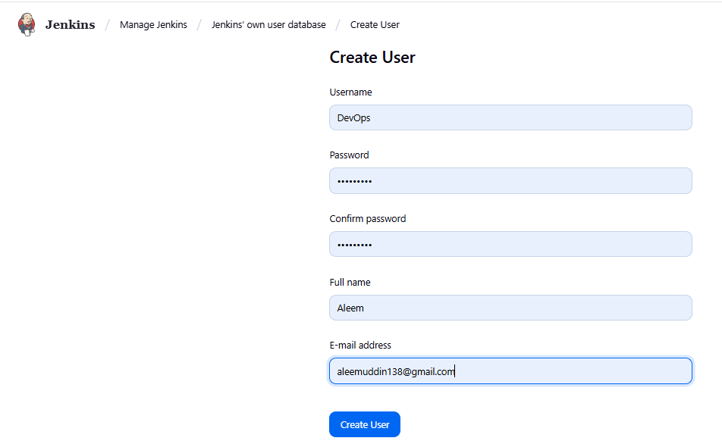

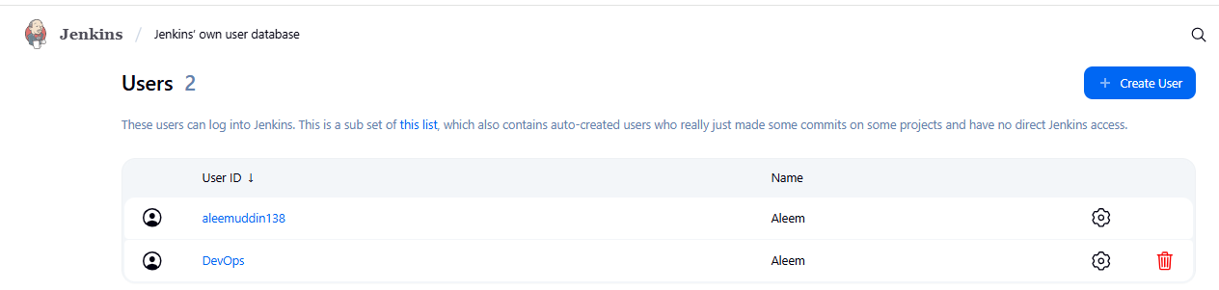

**Manage jenkins → security → authorization(project-based…..)**

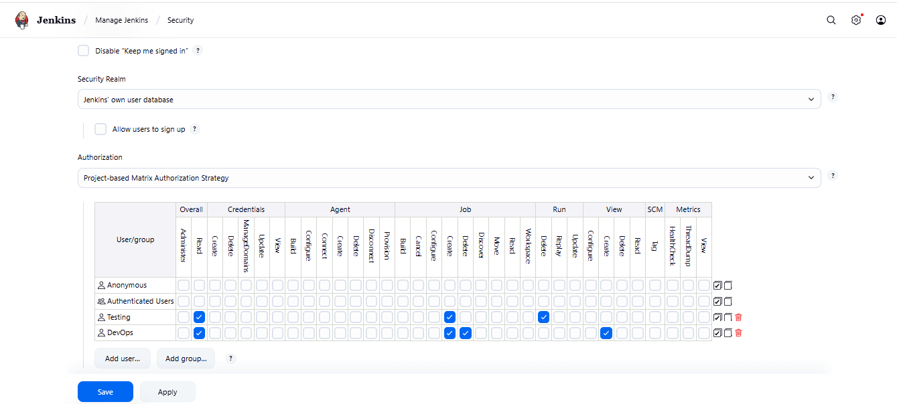

**DevOps Account**

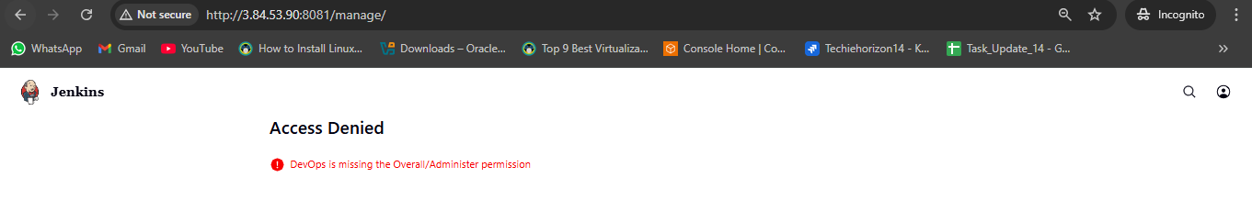

**Testing Account**

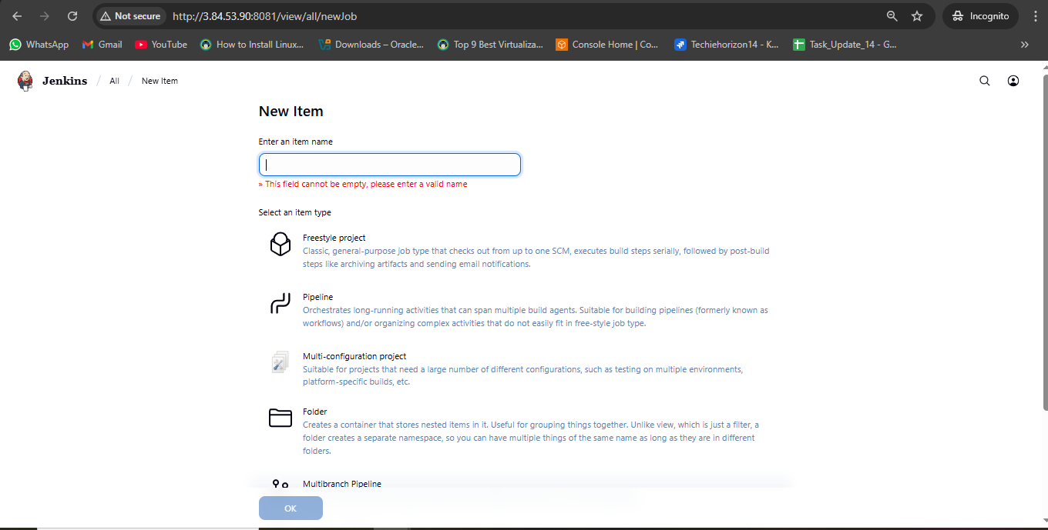

**4) Configure labels and restrict the jobs to execute based on label only.**

**Install GIT**

**Manage jenkins → system → create label Master**

**Create first job having label Master**

**Create second job without label Master**

**Create third job with wrong label hotfix**

**In each job → configure → build steps → execute shell → give seconds**

**I got an issue with disk space**

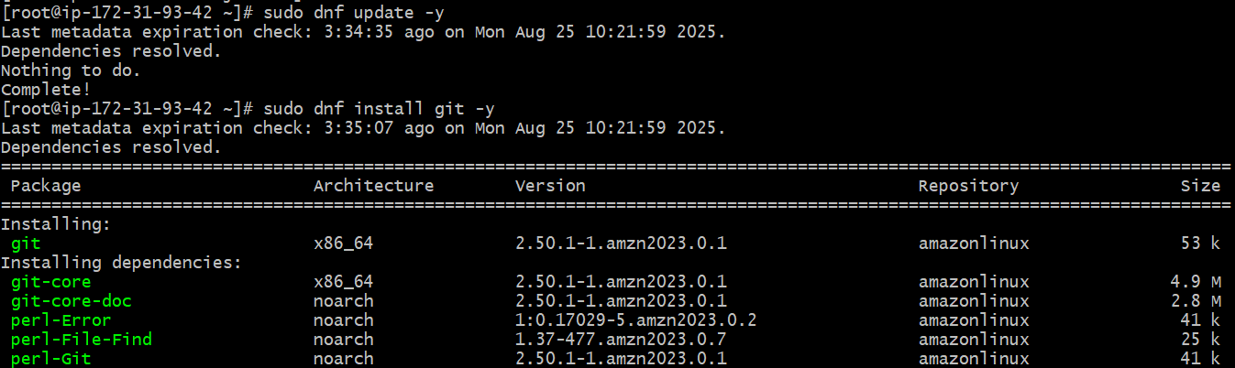

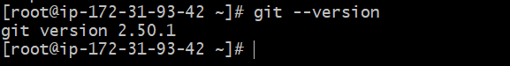

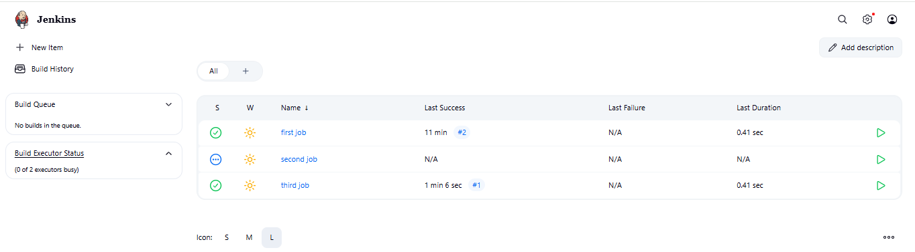

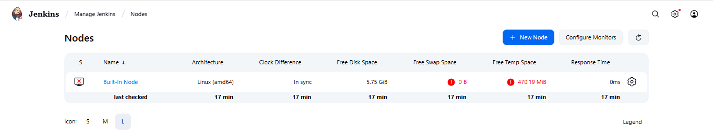

1. **Change Jenkins temporary directory (recommended)** 
   1. **Point Jenkins to use /var/lib/jenkins/tmp (on your main disk, which has ~18 GB free):**
   2. **Create a new tmp directory:  
      sudo mkdir -p /var/lib/jenkins/tmp**

**sudo chown -R jenkins:jenkins /var/lib/jenkins/tmp**

* 1. **Add below temp file → sudo systemctl edit jenkins**
  2. **[Service]**

**Environment="JAVA_OPTS=-Djava.io.tmpdir=/var/lib/jenkins/tmp"**

* 1. **Then reload**

**sudo systemctl daemon-reload**

**sudo systemctl restart jenkins**

**Install bitbucket plugin**

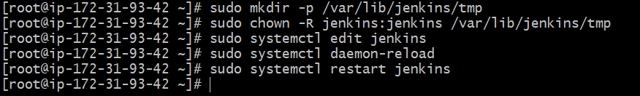

**First job only executed because it’s having label Master other jobs not connected to label Master**

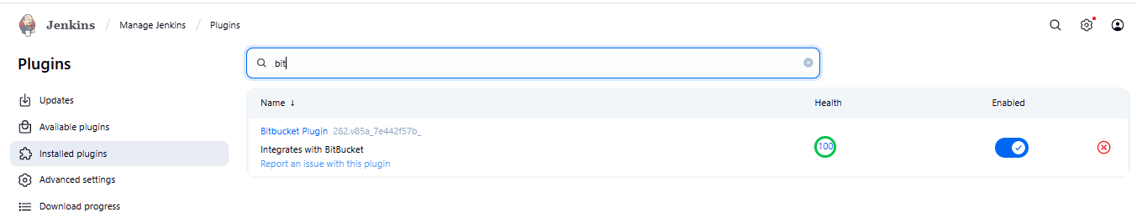

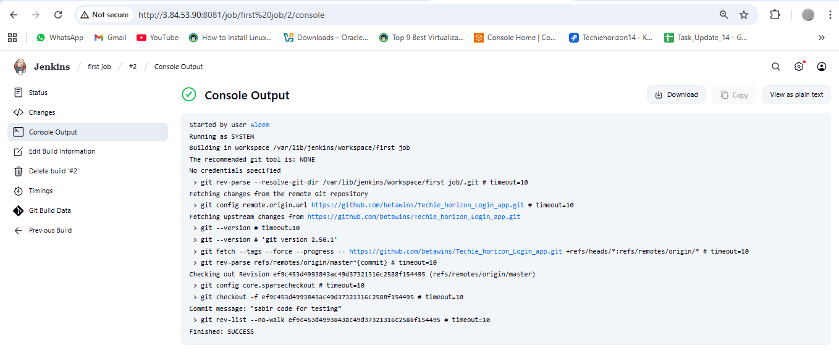

**5) Create Three sample jobs using the below URL.**[**https://github.com/betawins/Techie_horizon_Login_app.git**](https://github.com/betawins/Techie_horizon_Login_app.git)

**Created three different jobs with different time stamps with label master i already in jenkins configured label as master.**

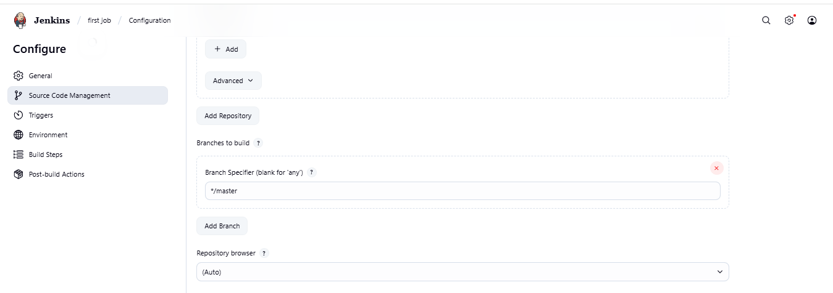

**Taken above url and once created then do build**

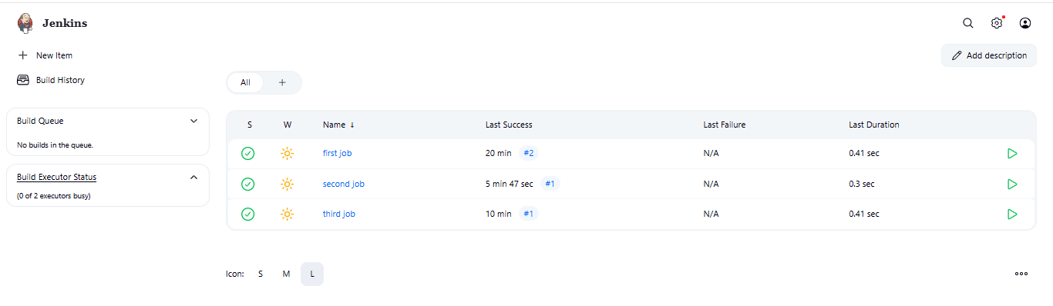

**6) Create one Jenkins job using git hub Private repository.**

**GitHubGitHub**

[**GitHub - betawins/Techie_horizon_Login_app**](https://github.com/betawins/Techie_horizon_Login_app.git)

**Contribute to betawins/Techie_horizon_Login_app development by creating an account on GitHub. (33 kB)**

**Go to github and create access token with repo**

**Goto → github → settings → developer settings → personal access token (pat) → Tokens (Classic) → Generate new token → Generate new token (Classic)**

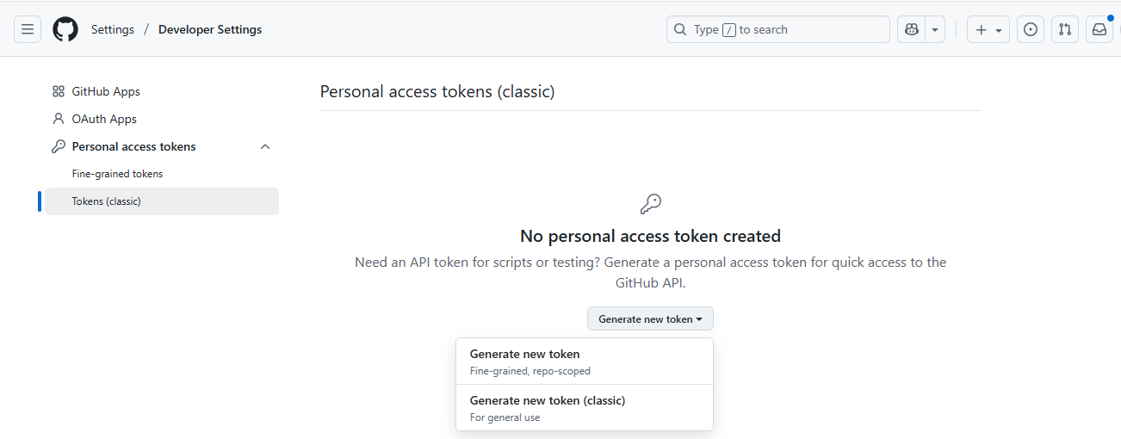

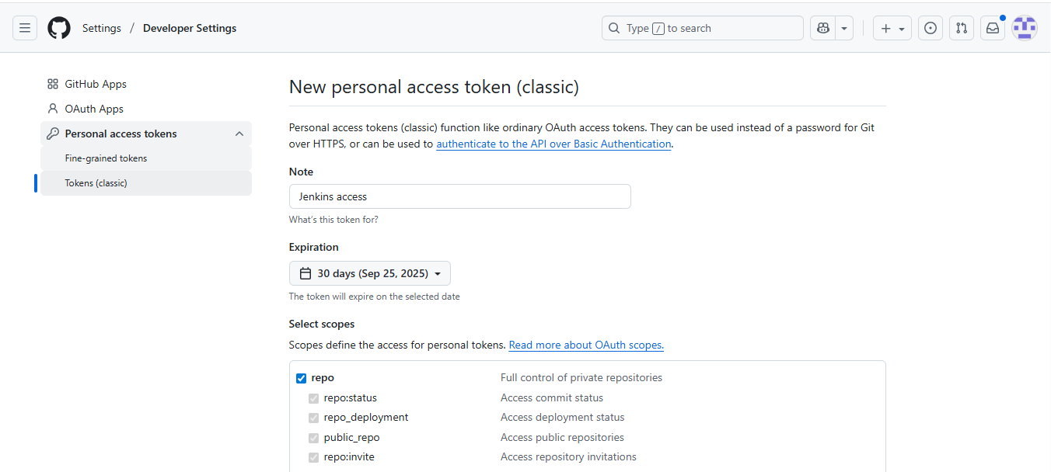

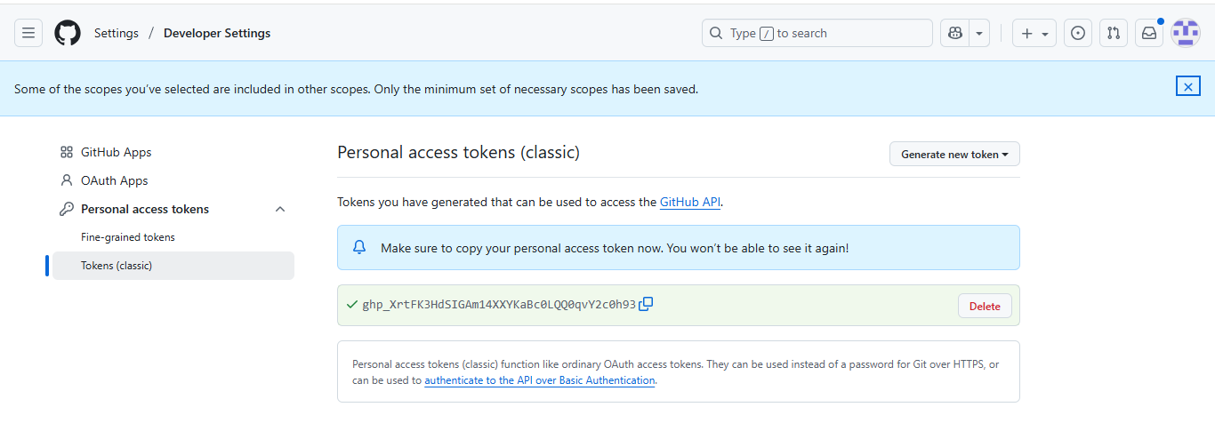

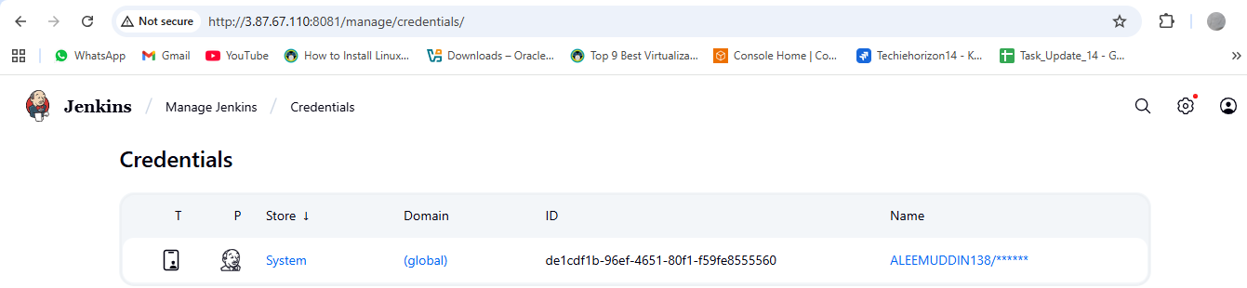

**Copy the PAT, github URL & add the credentials then configuration**

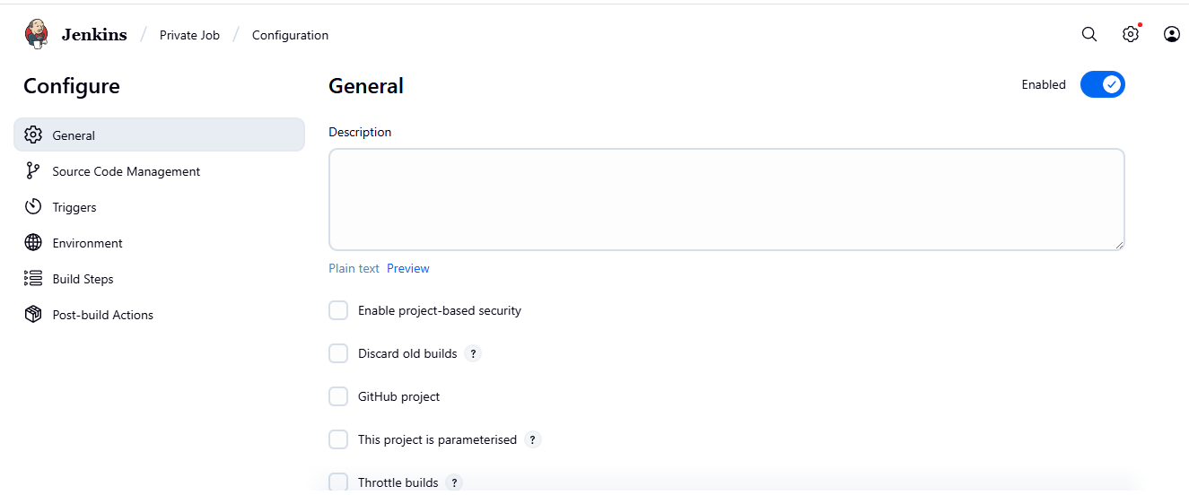

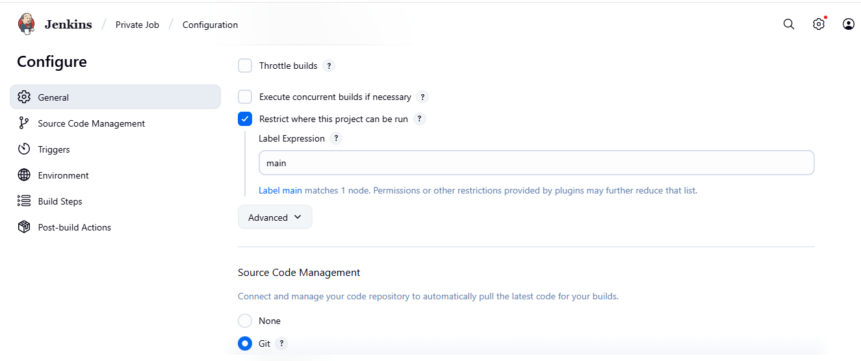

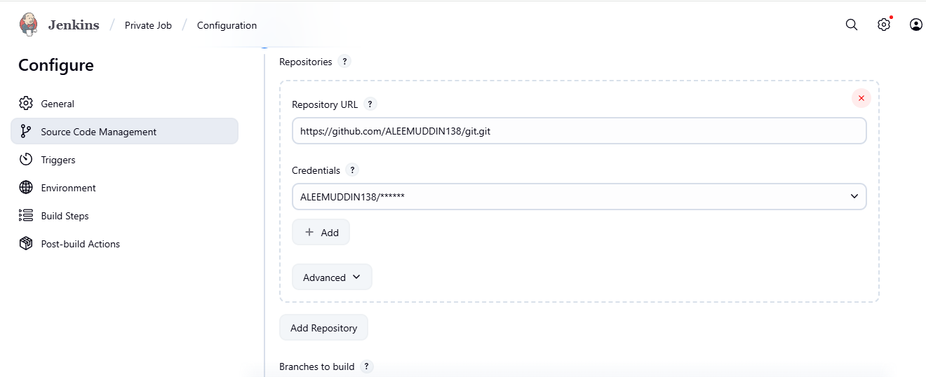

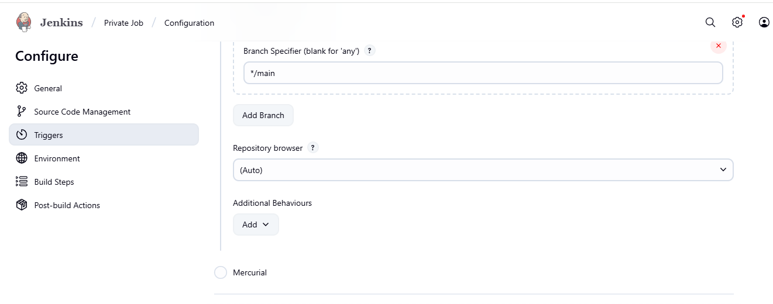

**Here go to Manage Jenkins > System**

**Follow the path and setup the Lable and required settings**

**Example: github branch name like Main, Master or Hotfix etc**

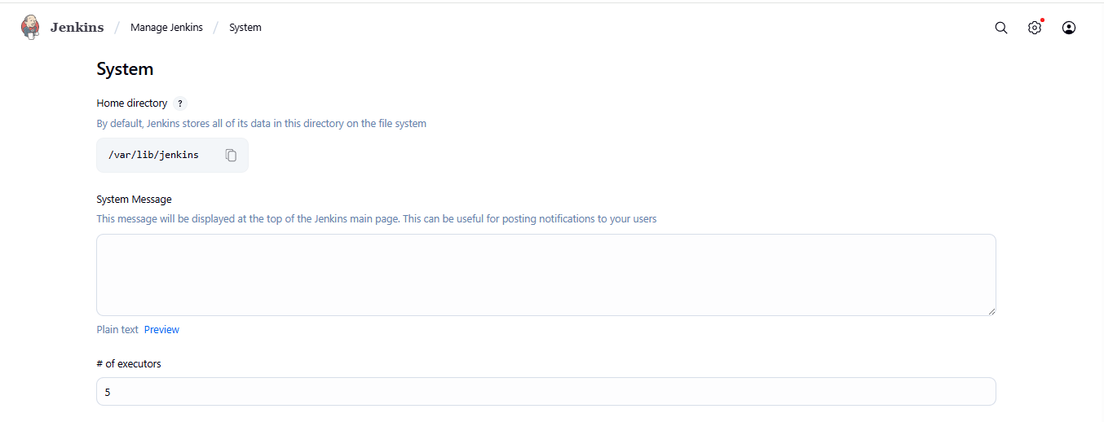

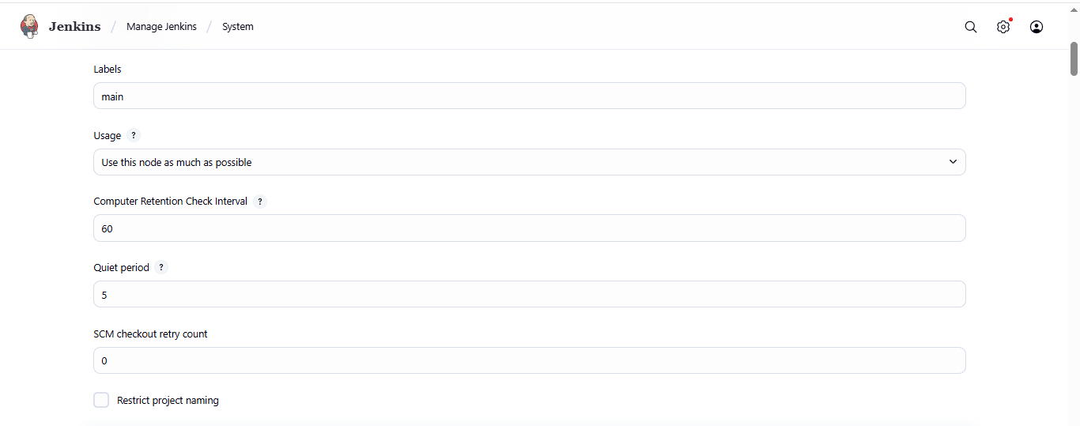

**Get the private repo outcome after Build the Job**

